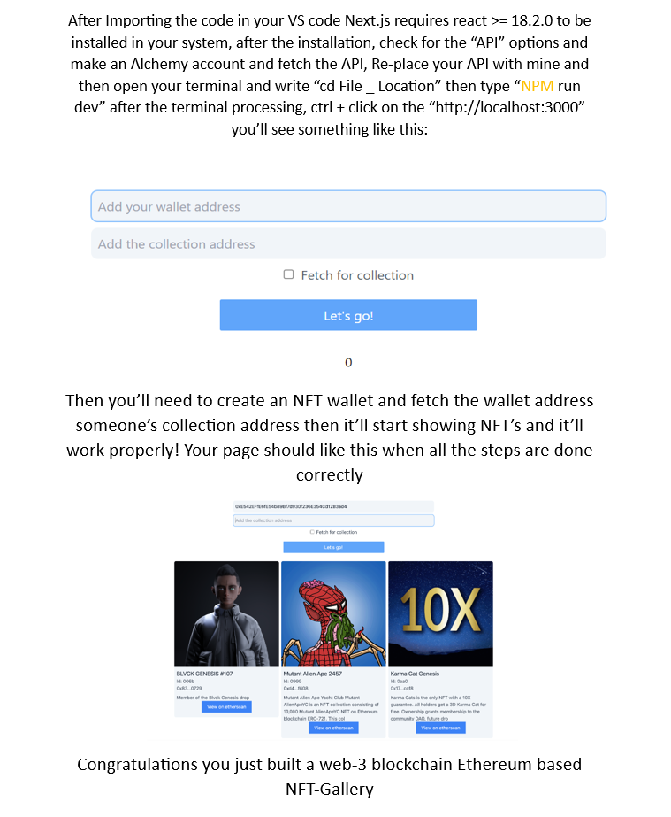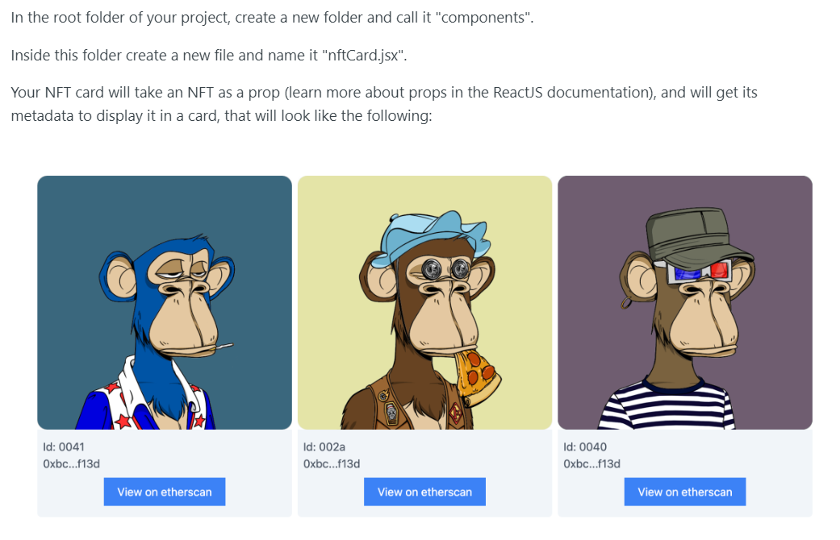
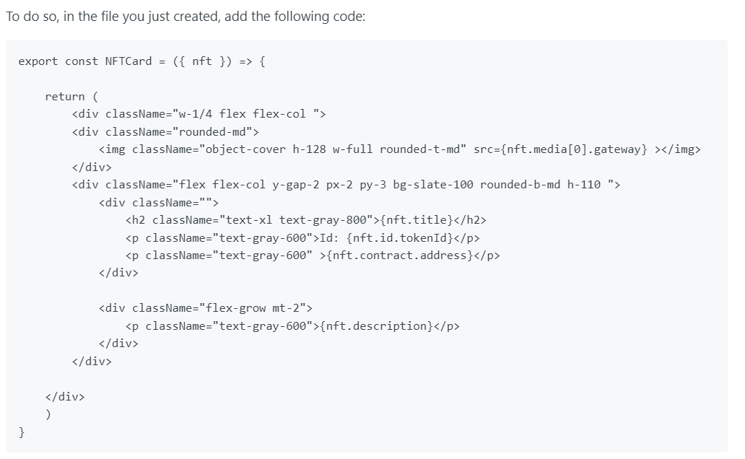

Here's how to get the NFT image:
• access the first index of the media object
• access the gateway property inside of it to get the image URL
• assign the image URL to the img tag in the code above "media[0].gateway"
To access the NFT title you'll only need to access the title property inside the NFT object itself.
With your NFT card, go to your home.jsx file and import it to create the NFT Gallery.

In the pages>index.js file, right under your button, import the following code:

import { NFTCard } from "../components/nftCard"
import { useState } from 'react'

const Home = () => {
const [wallet, setWalletAddress] = useState("");
const [collection, setCollectionAddress] = useState("");
const [NFTs, setNFTs] = useState([])
const [fetchForCollection, setFetchForCollection]=useState(false)

return (
<div className="flex flex-col items-center justify-center py-8 gap-y-3">
<div className="flex flex-col w-full justify-center items-center gap-y-2">
<input disabled={fetchForCollection} type={"text"} placeholder="Add your wallet address"></input>
<input type={"text"} placeholder="Add the collection address"></input>
<label className="text-gray-600 "><input onChange={(e)=>{setFetchForCollection(e.target.checked)}} type={"checkbox"} className="mr-2"></input>Fetch for collection</label>
<button className={"disabled:bg-slate-500 text-white bg-blue-400 px-4 py-2 mt-3 rounded-sm w-1/5"} onClick={
() => {
if (fetchForCollection) {
fetchNFTsForCollection()
}else fetchNFTs()
}
}>Let's go! </button>
</div>
<div className='flex flex-wrap gap-y-12 mt-4 w-5/6 gap-x-2 justify-center'>
{
NFTs.length && NFTs.map(nft => {
return (
<NFTCard nft={nft}></NFTCard>
)
})
}
</div>
</div>
)
}
export default Hom
Here is what is happening in this code:
- The NFTCard was imported at the top of your file.
- Inside the home page component, a new div was created, we opened the curly braces, and checked if there are NFTs in our state variable using conditional rendering.
- We used the map function to iterate over the array of NFTs and return an NFTCard for every NFT, passing the NFT itself as a prop of the NFTCard.

